Lab Exercise 6- Deployments with Rolling Update and Recreate Strategies

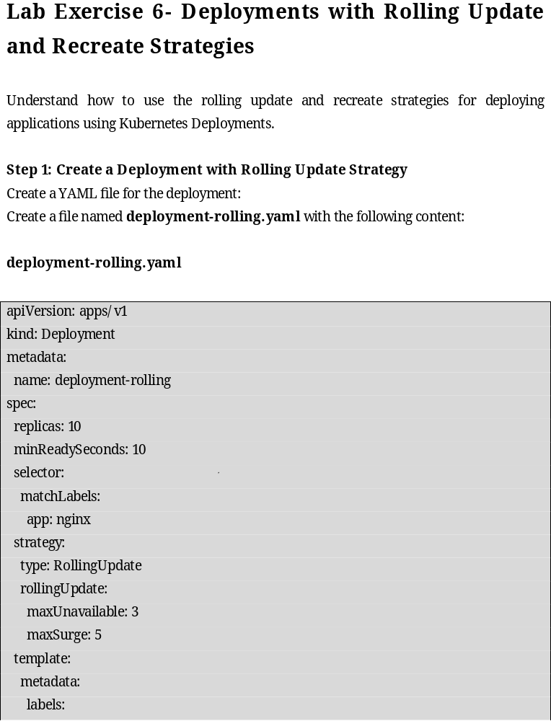Understand how to use the rolling update and recreate strategies for deploying applications using Kubernetes Deployments.
Step 1: Create a Deployment with Rolling Update Strategy
Create a YAML file for the deployment:
Create a file named deployment-rolling.yaml with the following content:

deployment-rolling.yaml

apiVersion: apps/v1
kind: Deployment
metadata:
name: deployment-rolling
spec:
replicas: 10
minReadySeconds: 10
selector:
matchLabels:
app: nginx
strategy:
type: RollingUpdate
rollingUpdate:
maxUnavailable: 3
maxSurge: 5
template:
metadata:
labels:
app: nginx
spec:
containers:
- name: my-container
image: hkshitesh/kubedemo:1.0

Apply the deployment:

kubectl apply -f deployment-rolling.yaml

Verify the deployment:

kubectl get deployments

Step 2: Create a Deployment with Recreate Strategy

Create a YAML file for the deployment:

Create a file named deployment-recreate.yaml with the following content:

deployment-recreate.yaml

apiVersion: apps/v1
kind: Deployment
metadata:
name: deployment-recreate
spec:
replicas: 10
selector:
matchLabels:
app: nginx
strategy:
type: Recreate
template:
metadata:
labels:
app: nginx
spec:
containers:
- name: my-container
image: hkshitesh/kubedemo:1.0

Apply the deployment:

kubectl apply -f deployment-recreate.yaml

Verify the deployment:

kubectl get deployments

Step 3: Clean Up

Delete the deployments:

kubectl delete deployment deployment-rolling
kubectl delete deployment deployment-recreate

Verify that all resources are cleaned up:

kubectl get deployments

